AUTOMATED COLOUR SORTING SYSTEM

TEAM MEMBERS:

1. VARUN KUMAR P - SEC22ME093
2. SHARMILA S - SEC22ME045
3. SANKAR DURAI N - SEC23ME082



SRI SAIRAM ENGINEERING COLLEGE,

SAI LEO NAGAR, WEST TAMBARAM

CHENNAI-44

**TABLE OF CONTENTS**

|  |  |
| --- | --- |
| **S.NO** | **TOPICS** |
| 1  1.1  1.2  1.3  1.4 | INTRODUCTION  BACKGROUND  OBJECTIVE  SCOPE  OVERVIEW OF THE SYSTEM |
| 2  2.1  2.2  2.3 | LITERATURE REVIEW  Existing Colour Sorting Systems  Working Principle of Colour Sensors:  Applications of Colour Sorting |
| 3  3.1  3.2  3.3 | SYSTEM DESIGN  Block Diagram  The system consists of  Working Principle |
| 4  4.1  4.2  4.3  4.4  4.5  4.6  4.7 | COMPONENTS USED  Arduino UNO  TCS3200 Colour Sensor  IR Sensor  LCD I2C Display  Servo Motors  DC Motors In Conveyor System  Power Supply (9V) |
| 5  5.1  5.2 | CIRCUIT DIAGRAM AND WIRING  Circuit Diagram  Connection Details |
| 6  6.1  6.2 | WORKING OF THE SYSTEM  Colour Detection Process  Sorting Mechanism |
| 7  7.1  7.2 | SOFTWARE INFORMATION  Arduino Code Explanation  Flowchart |
| 8  8.1  8.2 | RESULTS AND DISCUSSION  Observations  Accuracy Analysis |
| 9  9.1 | CONCLUSION AND FUTURE WORK  Summary |

1**. INTRODUCTION:**

**1.1 Background:**

In industries where sorting of coloured objects is required, manual sorting can be slow, error-prone, and inefficient. Automating the sorting process using embedded systems and sensors can improve accuracy and speed. Traditional manual sorting methods are often time-consuming, labor-intensive, and prone to errors. To address these challenges, an Automated Colour Sorting System has been designed and developed.The Automated Colour Sorting System utilizes advanced technologies, including computer vision, machine learning, and robotics, to efficiently and accurately sort objects based on their color. This system has numerous applications in various industries, including:

- Manufacturing: Sorting of parts and components based on color.

- Recycling: Separation of recyclable materials based on color.

- Food Processing: Sorting of fruits and vegetables based on color.

**1.2 Objective:**

The primary objective of the Automated Colour Sorting System is to design and develop an efficient, accurate, and reliable system for sorting objects based on their color. The system aims to minimize manual labor, reduce errors, and increase productivity.

**1.3 Scope:**

The scope of the Automated Colour Sorting System includes:

- Design and development of a computer vision-based color detection system.

- Integration of machine learning algorithms for accurate color classification.

- Development of a robotic sorting mechanism for efficient object sorting.

- Testing and evaluation of the system's performance and accuracy.

**1.4 Overview of the System:**

The Automated Colour Sorting System consists of several key components, including:

- Color Detection System: Utilizes computer vision and machine learning algorithms to detect and classify the color of objects.

- Robotic Sorting Mechanism: Employs robotic arms or conveyor belts to sort objects based on their color.

- Control System: Integrates sensors, actuators, and control algorithms to manage the sorting process.

The Automated Colour Sorting System offers numerous benefits, including increased efficiency, accuracy, and productivity, as well as reduced manual labor and errors.

2. LITERATURE REVIEW:

**2.1 Existing Colour Sorting Systems:**

Colour sorting machines are widely used in industries such as food processing, recycling, and manufacturing. Traditional methods involve manual sorting or expensive vision-based systems.

**2.2 Working Principle of Colour Sensors:**

The TCS3200 colour sensor detects colour by measuring the intensity of red, green, and blue light reflected from an object. It converts the colour data into a frequency output, which is processed by the Arduino UNO.

**2.3 Applications of Colour Sorting:**

1) Food industry (sorting grains, fruits, vegetables)

2)Waste management (plastic and paper separation)

3)Manufacturing (quality control and product classification)

**3. SYSTEM DESIGN:**

**3.1 Block Diagram:**

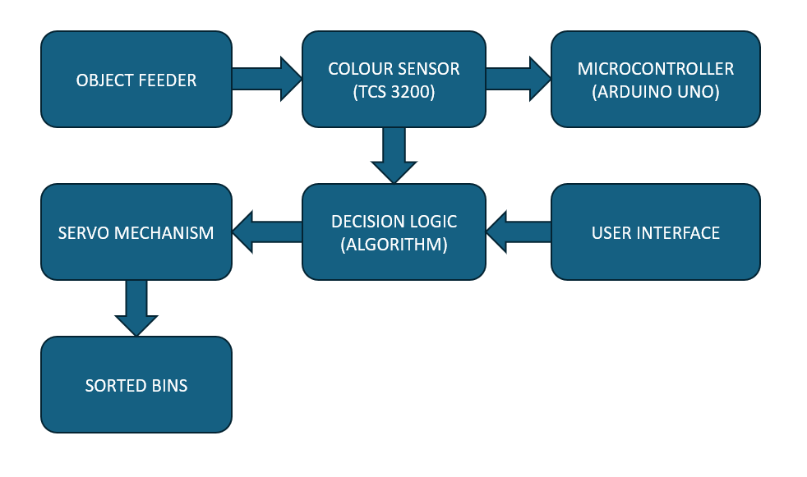

**3.2 The system consists of:**

1) Input Sensors: TCS3200 (colour detection) and IR sensor (object detection).

2) Processing Unit: Arduino UNO to process sensor data and control actuators.

3) Actuators: DC motors (conveyor movement) and servo motors (sorting).

**3.3 Working Principle:**

1) The IR sensor detects an object on the conveyor.

2) The TCS3200 sensor reads the colour of the object.

3) Arduino processes the data and determines the colour.

4) The LCD displays the detected colour.

5) The servo motor moves the object to the respective bin based on the colour detected.

**4. COMPONENTS USED:**

**4.1 Arduino UNO:**

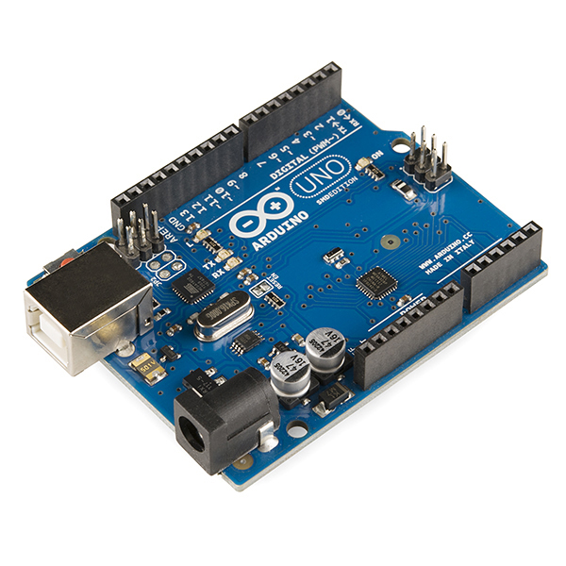

Arduino UNO is the main microcontroller used for processing sensor data and controlling the motors.

**4.2 TCS3200 Colour Sensor:**

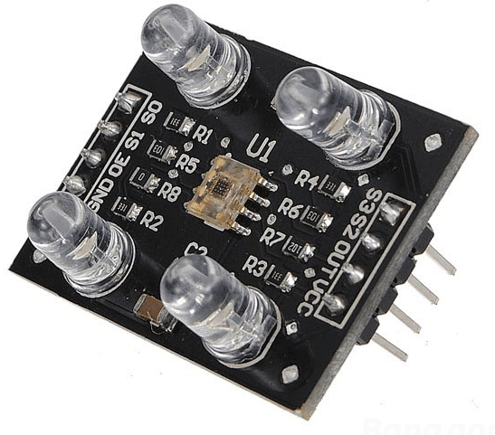

This sensor detects the colour of objects using photodiodes and provides a frequency output corresponding to different colours.

**4.3 IR Sensor:**

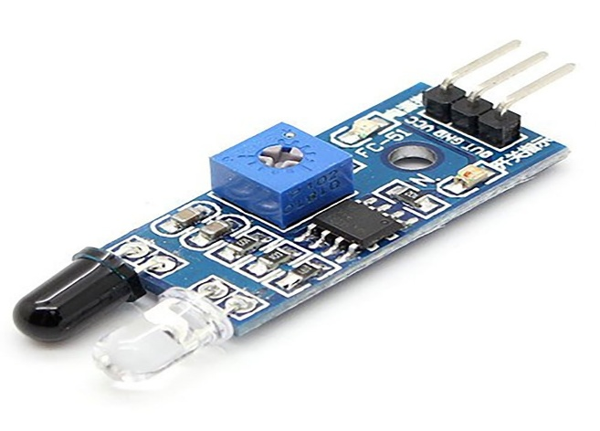

Used to detect the presence of an object before colour detection.

**4.4 LCD I2C Display:**

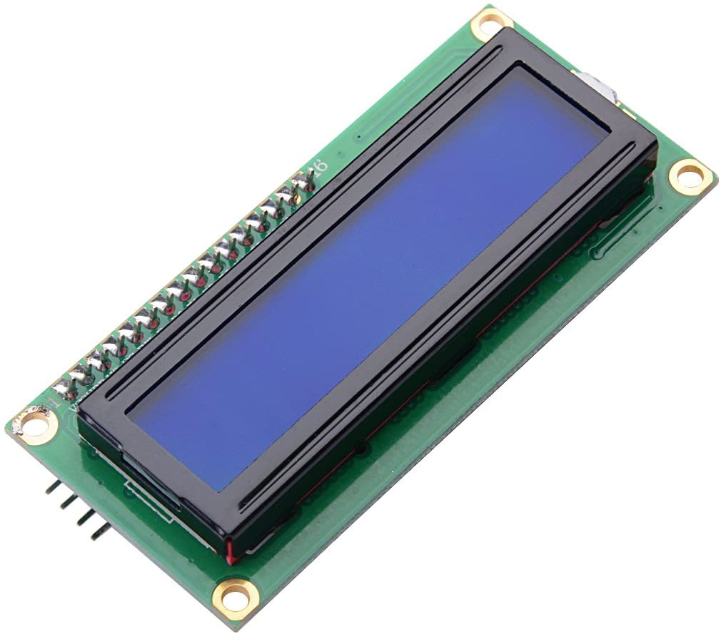

Displays the detected colour and system status.

**4.5 Servo Motors:**

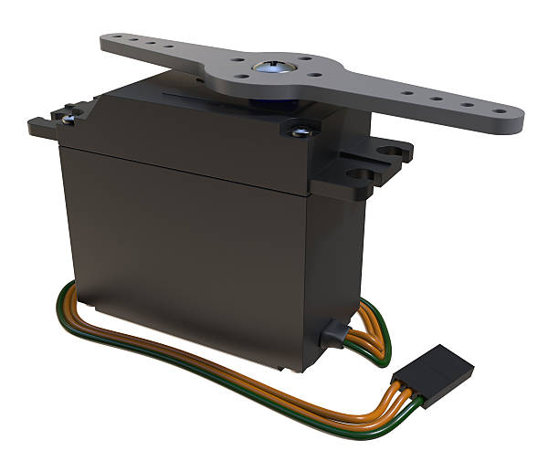

Used for sorting objects into bins based on their colour.

**4.6 DC Motors in Conveyor System:**

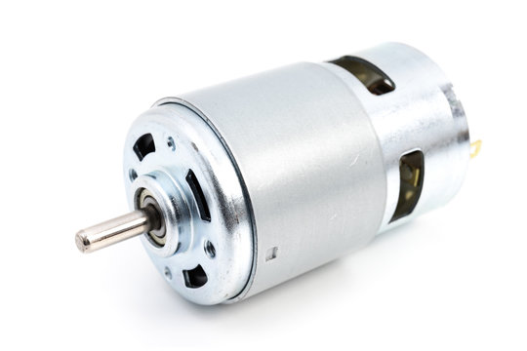

DC motors drive the conveyor belt to move objects towards the sensor.

**4.7 Power Supply (9V):**

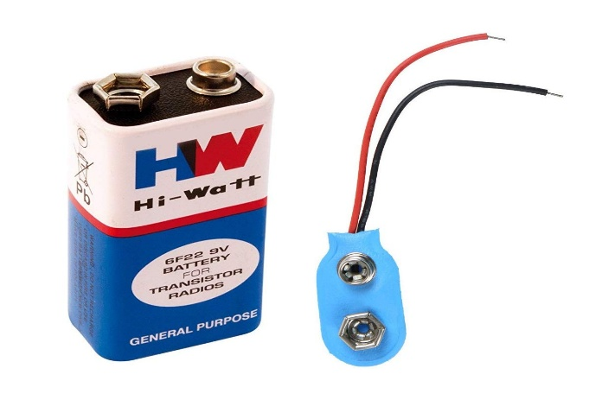

Provides power to Arduino and other components.

**5. CIRCUIT DIAGRAM AND WIRING :**

**5.1 Circuit Diagram:**

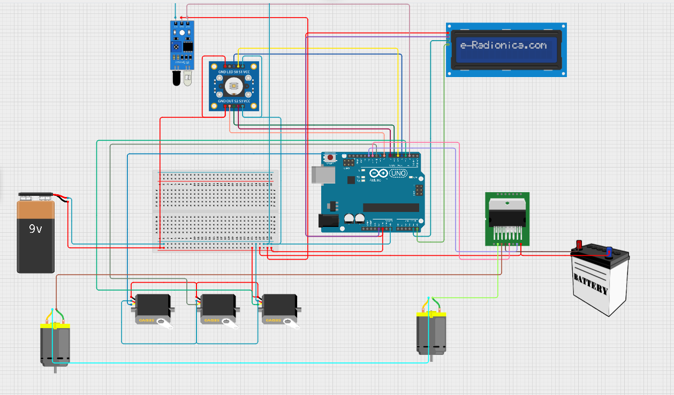

**5.2 Connection Details:**

1) **TCS3200 Sensor:** Connected to Arduino’s digital pins.

2) **IR Sensor:** Connected to Arduino’s input pin.

3) **LCD Display:** Connected via I2C communication.

4)**Servo Motors:** Controlled by PWM pins of Arduino.

5) **DC Motors:** Driven by an H-Bridge motor driver.

**6. WORKING OF THE SYSTEM:**

**6.1 Colour Detection Process:**

1)The TCS3200 sensor detects the RGB values of an object.

2)The Arduino processes the frequency output and determines the colour.

3)Based on pre-defined thresholds, it categorizes the object into red, green, or blue.

**6.2 Sorting Mechanism:**

After colour detection, the Arduino activates the appropriate servo motor to direct the object into a designated bin.

7. SOFTWARE INFORMATION:

**7.1 Arduino Code Explanation:**

The Arduino code includes:

1)Reading frequency values from the TCS3200 sensor.

2)Using conditional statements to determine object colour.

3)Displaying the colour on the LCD.

4)Controlling servos and conveyor movement.

**7.2 Flowchart:**

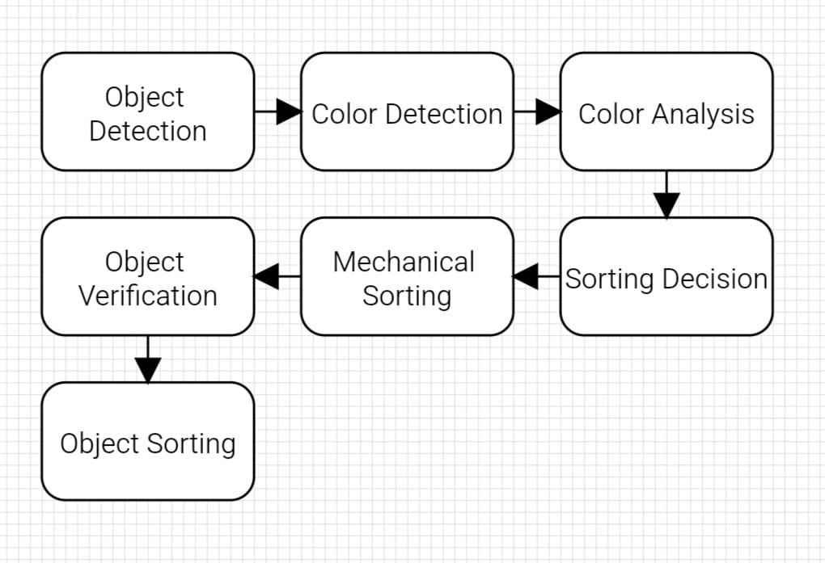

**8. RESULTS AND DISCUSSION:**

**8.1 Observations:**

1)The system correctly detected and sorted objects into different bins.

2)Sorting accuracy depended on lighting conditions and sensor calibration.

**8.2 Accuracy Analysis:**

The system achieved an accuracy of approximately 90% in sorting-coloured objects correctly. Minor errors were observed due to ambient light interference.

**9. CONCLUSION AND FUTURE WORK:**

**9.1 Summary:**

This project successfully implemented a low-cost automated colour sorting system using Arduino and sensors. It demonstrated efficient sorting based on colour detection.